DMart Sales Analysis Dashboard Using Power BI
1. Introduction
This project analyzes DMart sales data using Power BI to understand business performance. The goal of the dashboard is to identify sales trends, profitable categories, and top-performing locations. Power BI helps convert raw sales data into meaningful insights through interactive visualizations.

2. Data Source
The dataset used in this project is a DMart sales dataset in CSV format.
It contains information such as:
- Order ID
- Product Category
- Sales
- Profit
- Quantity
- Order Date
- Location (City/State)
This data is used to analyze sales performance and business trends.

3. Data Import and Data Cleaning
The dataset was imported into Power BI Desktop using the Get Data option.
After importing, the Power Query Editor was used to clean and transform the data.
Data cleaning steps included:
- Removing blank or unnecessary rows
- Correcting column names
- Changing data types (Date, Number, Text)
- Handling missing values
After cleaning the dataset, it was loaded into Power BI for analysis.

4. DAX Measures
Several DAX measures were created to calculate important business metrics such as:
- Total Sales
- Total Profit
- Total Quantity
- Profit Percentage
These measures help analyze the overall performance of the business and make the dashboard interactive.

5. Dashboard Pages
5.1 Overview Page
The Overview page provides a summary of overall business performance. It highlights key metrics such as total sales, total profit, and total orders. This page gives a quick understanding of the business performance.
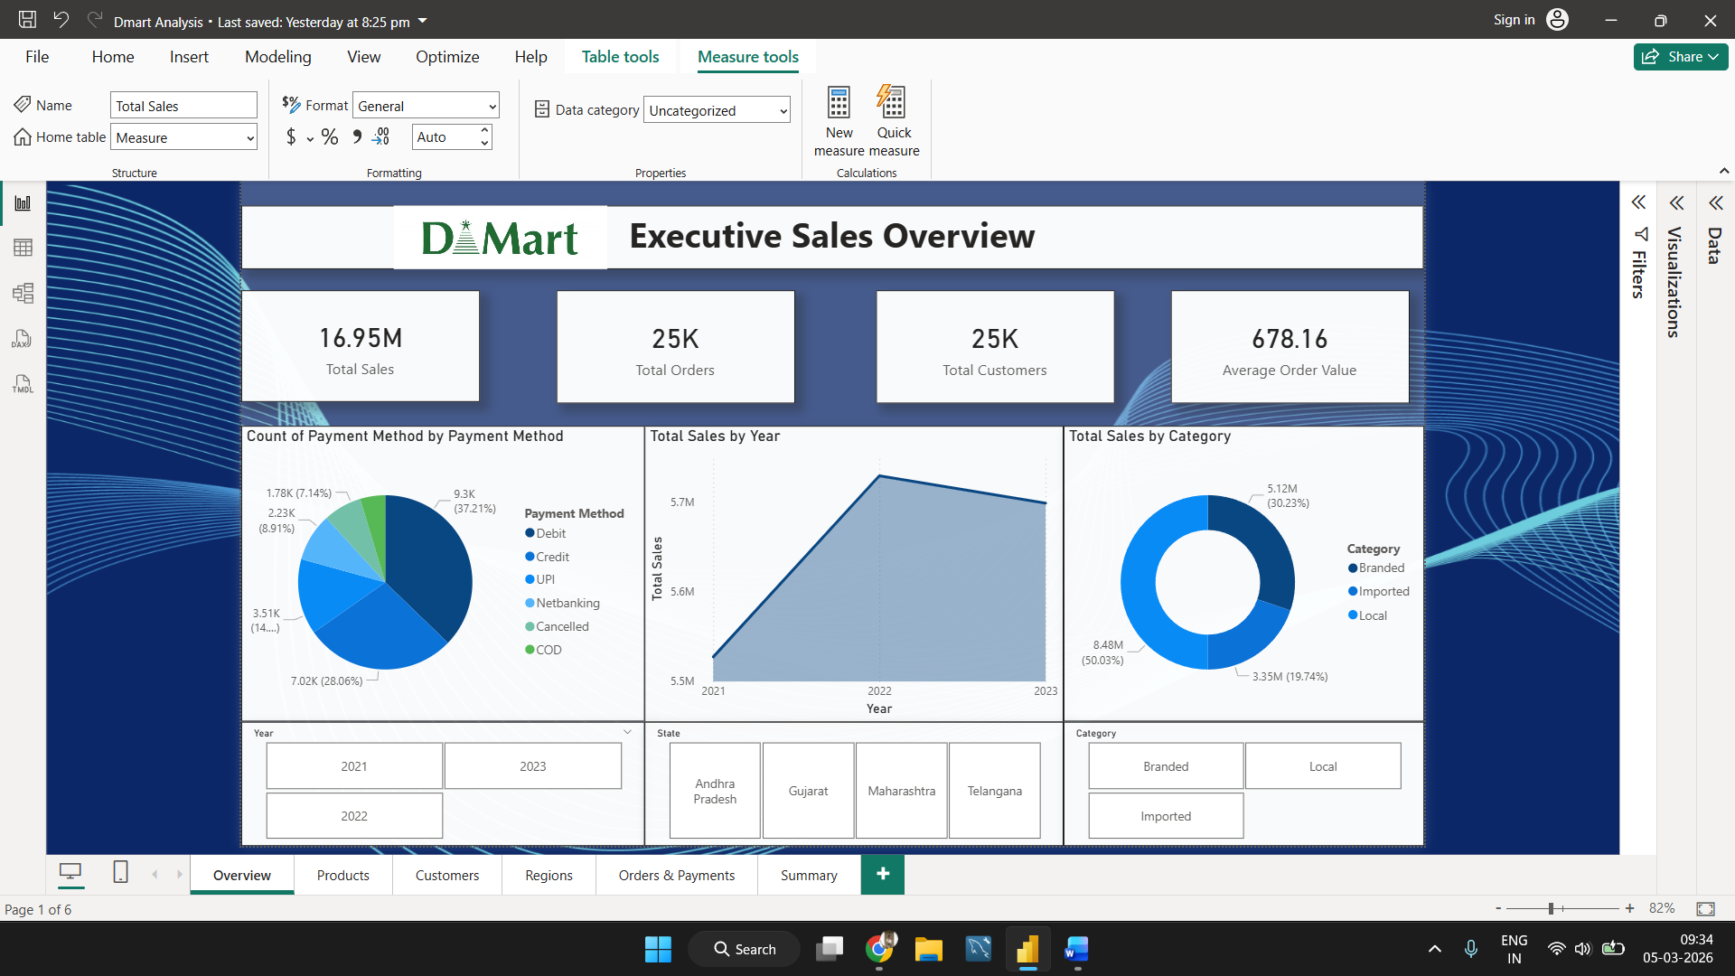
5.2 Products Page
The Products page analyzes product performance. It shows which product categories or products generate the highest sales and profit. This page helps identify best-selling products.
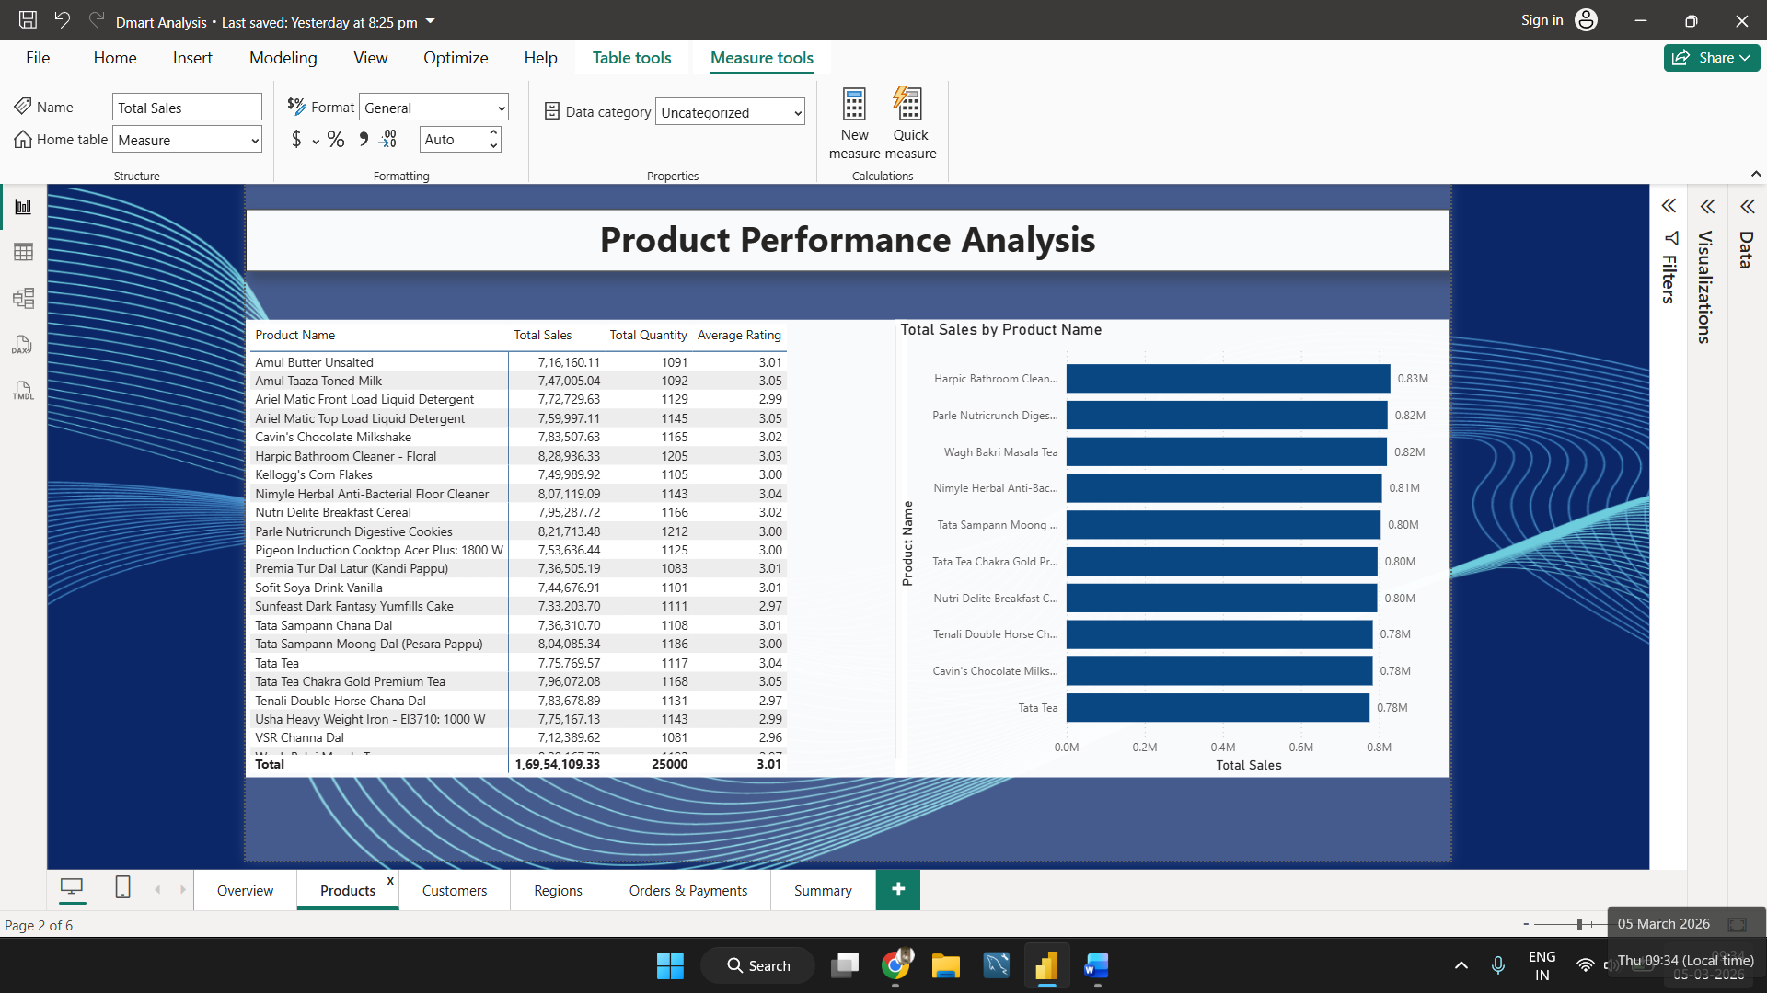
5.3 Customers Page
The Customers page focuses on customer-related analysis. It helps understand customer purchasing patterns and identifies top customers contributing the most to sales.
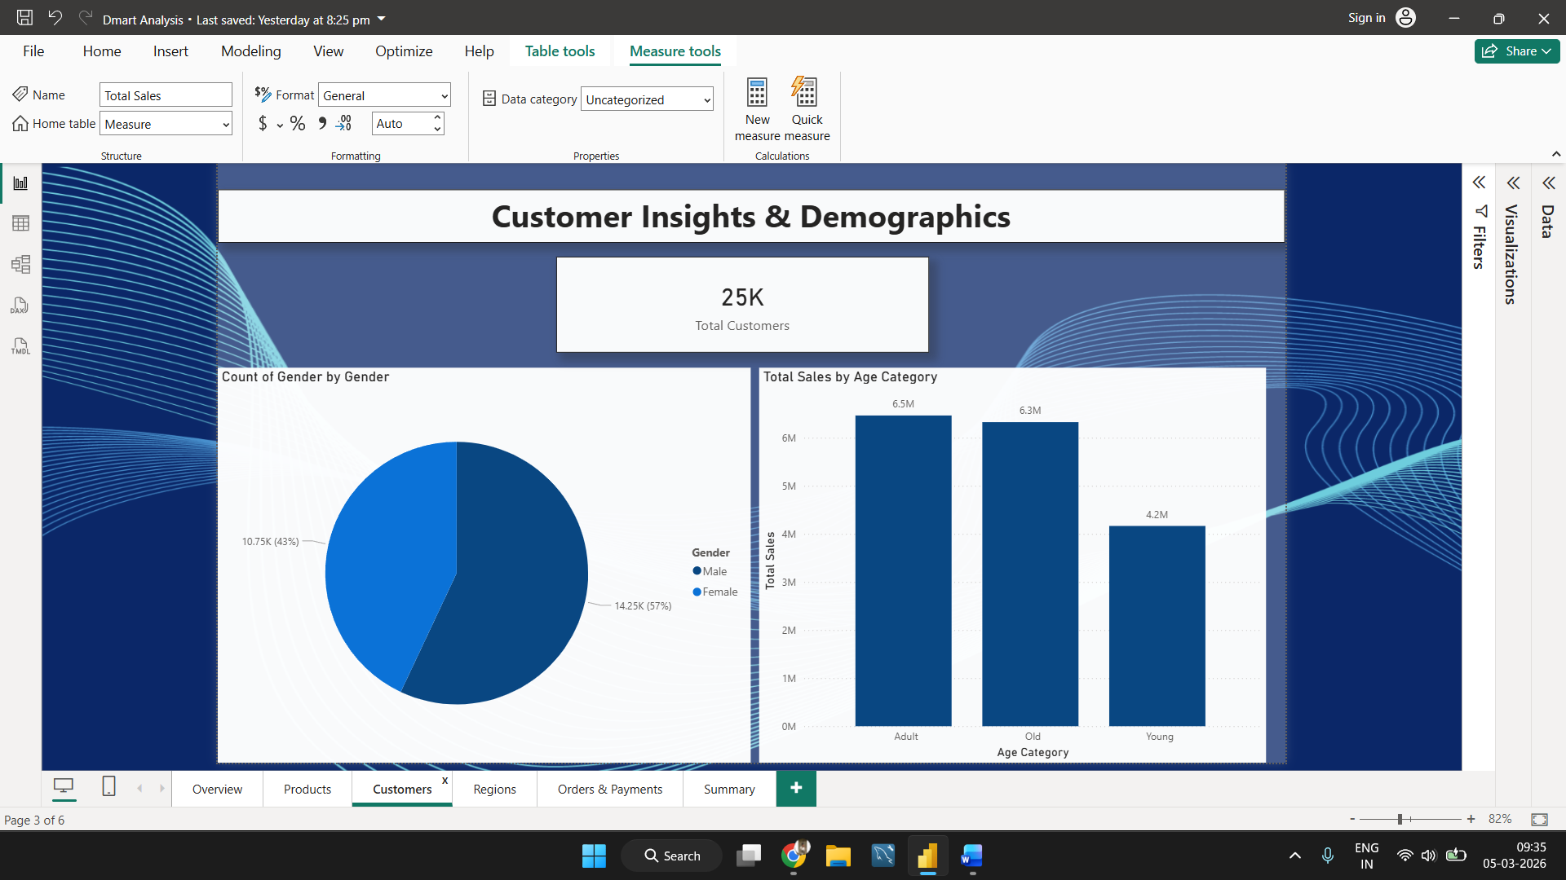
5.4 Regions Page
The Regions page analyzes sales performance based on different regions or locations. It helps identify which cities or regions contribute the highest revenue.
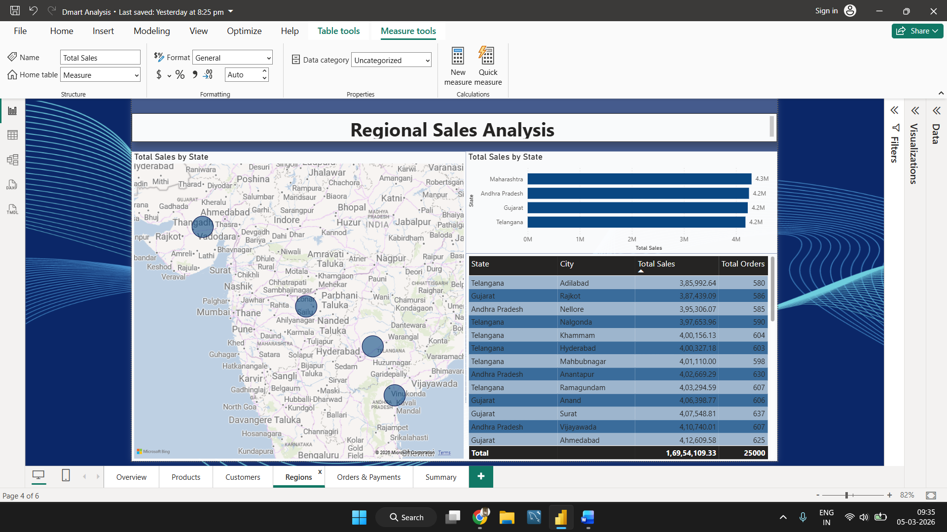
5.5 Orders & Payments Page
This page provides insights related to order details and payment information. It helps analyze order volume, payment methods, and transaction patterns.
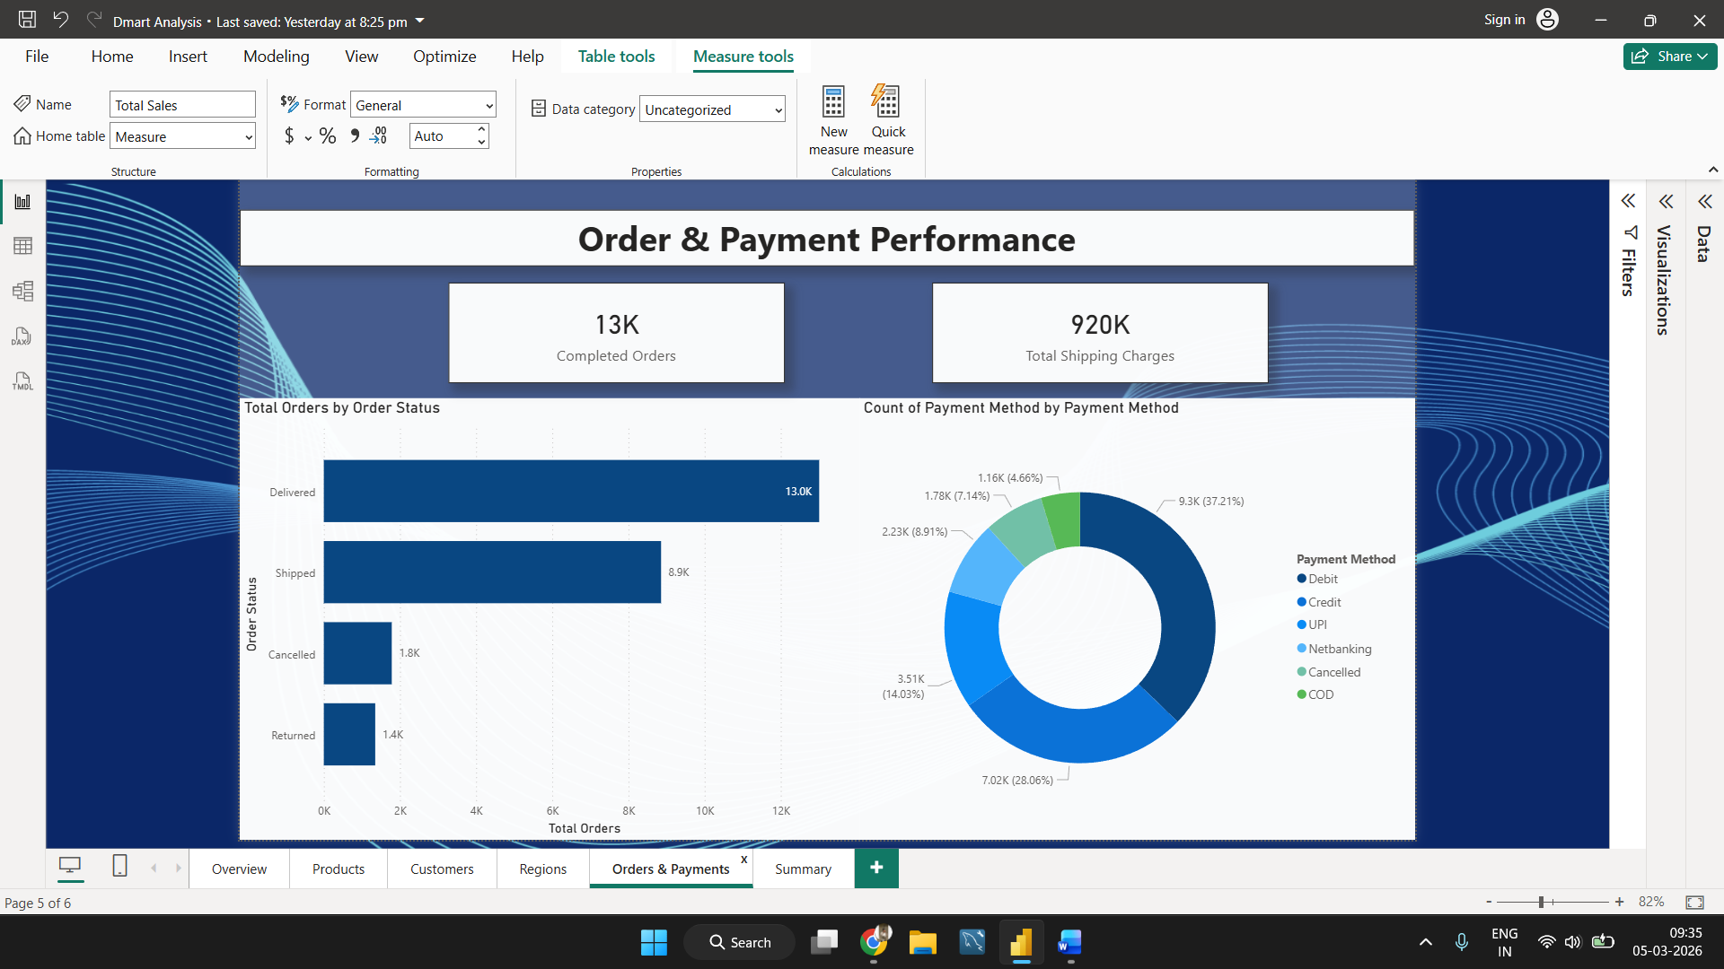

5.6 Summary Page
The Summary page provides the final insights from the entire dashboard. It highlights key findings related to sales performance, customer behavior, product performance, and regional trends. This page helps stakeholders quickly understand the overall business insights.
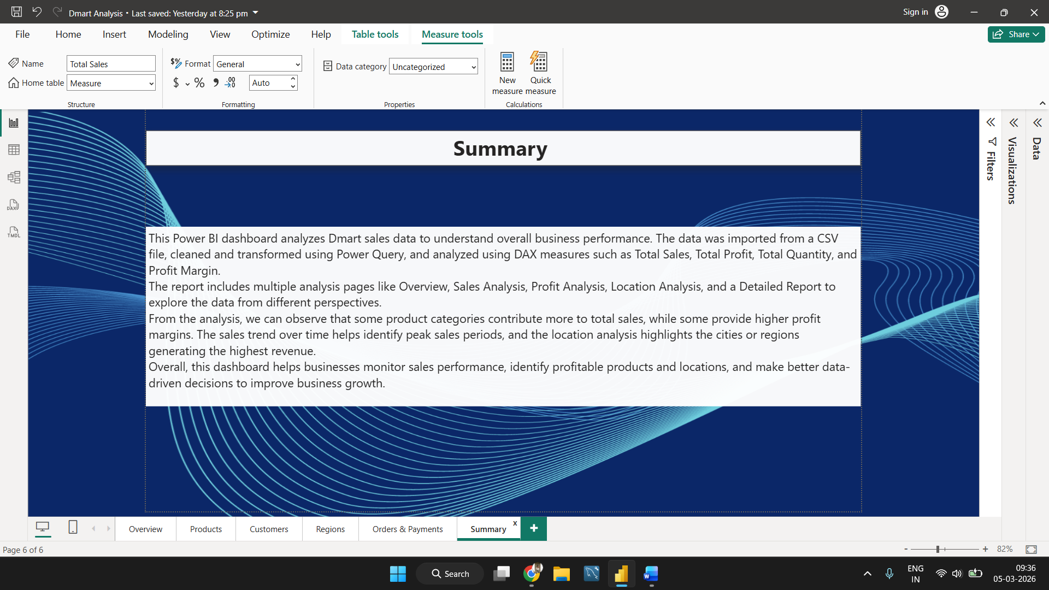
6. Key Insights
From the dashboard analysis, the following insights were identified:
- Some product categories contribute more to total sales.
- Certain products generate higher profits than others.
- Sales performance varies across different locations.
- Monthly trends help identify peak sales periods.

7. Conclusion
This Power BI dashboard helps visualize DMart sales performance and provides valuable insights into business trends. It enables better decision-making by identifying profitable products, high-performing locations, and sales patterns.

8. Publishing to Power BI Service
After completing the dashboard in Power BI Desktop, the report was published to Power BI Service to make it accessible online.
